DOCUMENT 11 — Knowledge-Graph Curation & Syllabus Mapping SOP
Visionary Internal · v1.0 · How official syllabi become teachable KG nodes

1. Curation flow
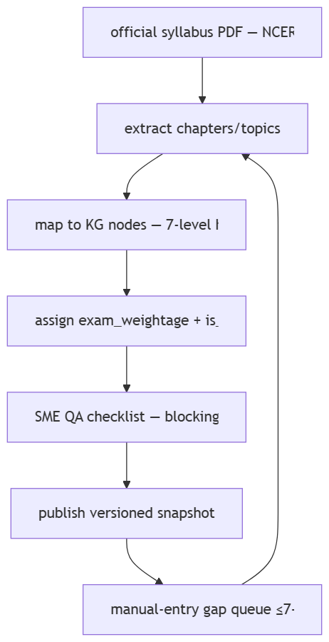

2. Mapping rules
- Hierarchy: Board → Class → Subject → Textbook → Chapter → Topic → Concept; one concept = one node; edges = prerequisite only (DAG, no cycles).
- medium_of_instruction per node; a concept exists once, languages are views.
- Competitive exams map onto NCERT nodes + add exclusions/weightage/advanced nodes (never duplicate base).
- Official sources only; every node stores data_source_url + last_verified_date; stale >12 months = re-verify.

3. QA checklist (blocking)
Chapter names match TOC exactly · chapter counts match · weightage from current-year doc only · latest textbook edition · is_in_current_syllabus cross-checked · subject naming per board · medium code ISO · source URL present · manual entries converted ≤7 days.

4. Coverage & priority
Phase 1 (days 1–10): CBSE + JEE + NEET + ICSE + JEE-Adv. Phase 2 (11–20): UP, MH, WB, TN, KA + CAT/UPSC. Phase 3 (21–30): remaining 36 boards/UTs + SSC/banking/railway/defence/teaching/GATE/CLAT.

OKF
KF1 0 wrong chapter names in prod · KF2 100% Phase-1 coverage before beta · KF3 gap-SLA ≥95% · KF4 versioned snapshots rollback-safe · KF5 provisional fallback never blocks a user (Doc 12).

